SIMATS ENGINEERING
ASSESSMENT TOOL 1 – INTERNET PROGRAMMING (CSA43)
Course Outcome CO-2: Apply CSS layout and styling techniques to create visually appealing and responsive web interfaces, and use JavaScript to enable interactive client-side behavior (L3).
Assessment Tool: Integrated Experiments Weightage: 40% Total Marks: 30
Code of Conduct
I Venkateswarlu-192411239(Name / Reg. No.) certify that this submission is my original work and that I have adhered to the guidelines specified for this assessment. I understand that any violation of academic integrity rules will result in disciplinary action.
Signature of the student:

Experiment 1: Responsive Layout Design
Aim: To design a responsive retail webpage using CSS Flexbox and media queries that adapts to mobile, tablet, and desktop screen sizes.
(a) Analyze the possible reasons for lack of responsiveness
The existing retail website may not be responsive due to the following reasons:
- Fixed-width layouts: Using fixed pixel values for containers can cause content to overflow on smaller screens.
- Missing media queries: Without media queries, the layout cannot adapt to different screen sizes.
- Improper image sizing: Large images may exceed the available screen width.
- Incorrect positioning: Excessive use of absolute positioning can cause elements to overlap.
- Poor spacing: Fixed margins and padding can create uneven spacing on mobile devices.
- Non-responsive navigation: A horizontal navigation bar may not fit on narrow screens.
Conclusion: A responsive design should use flexible widths, suitable CSS layouts, scalable images, and media queries.
(b) Design a responsive webpage using CSS Flexbox
The webpage contains a header, navigation bar, product section, and footer. Flexbox is used to arrange the products, while CSS provides alignment and spacing.
(c) Demonstrate layout adaptation using media queries
- Desktop: Products appear in a row with multiple columns.
- Tablet: Products are arranged in fewer columns.
- Mobile: Products are stacked vertically, and navigation links wrap when required.
Media queries such as @media (max-width: 768px) and @media (max-width: 480px) help adjust the layout for smaller screens.
(d) Implement spacing, alignment, and distribution
The following CSS techniques improve visual consistency:
- display: flex arranges items flexibly.
- justify-content: space-between distributes items horizontally.
- align-items: center aligns items vertically.
- gap provides consistent spacing between elements.
- padding creates space inside elements.
- margin creates space outside elements.
- max-width prevents content from becoming excessively wide.
(e) Evaluate the responsive design and suggest improvements
The responsive layout reduces horizontal scrolling and improves readability on different devices.
Further improvements:
- Use responsive images with max-width: 100%.
- Test the webpage at multiple screen widths.
- Add a collapsible navigation menu for small screens.
- Use accessible colors, readable fonts, and sufficient button sizes.
- Test the page in different browsers and on real mobile devices
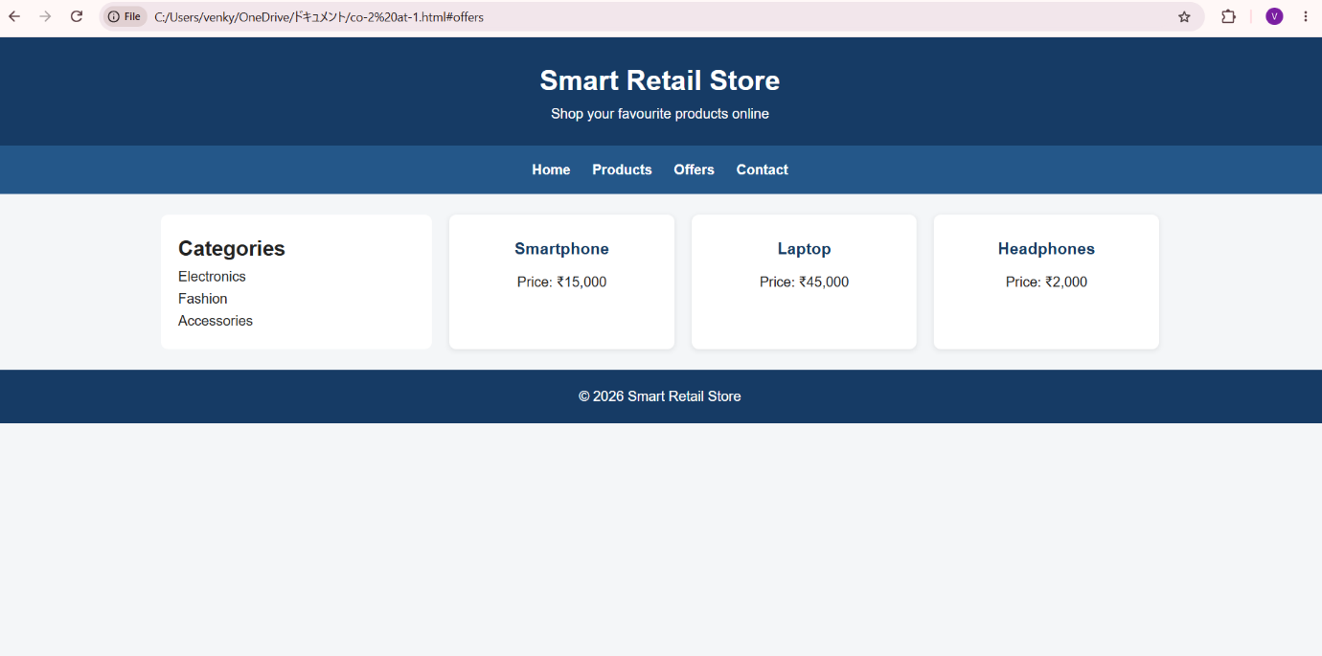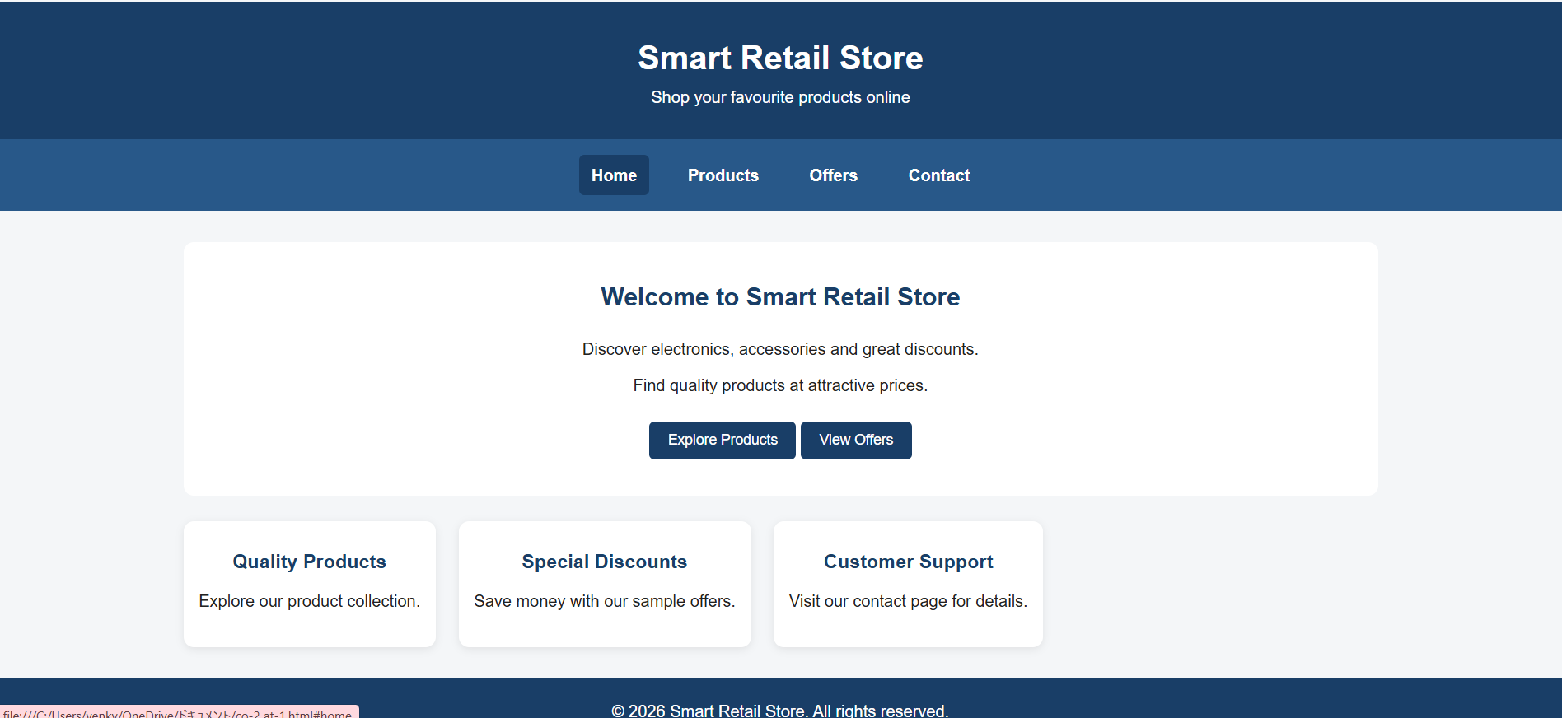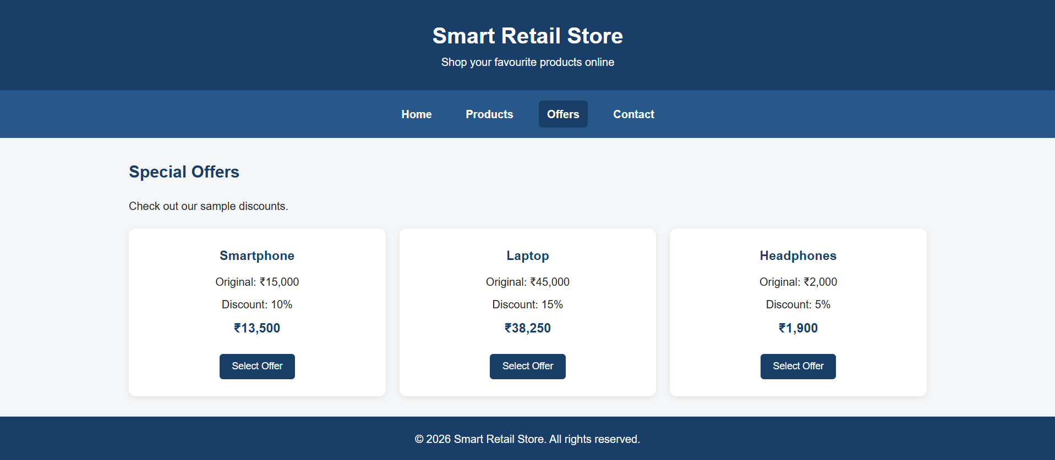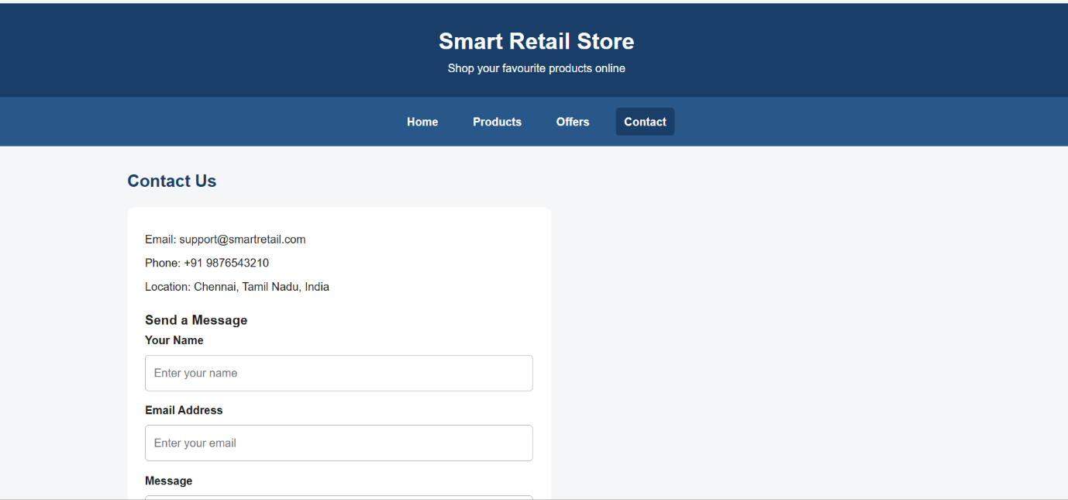
Experiment 2: Form Validation Using JavaScript
Aim: To validate email addresses and phone numbers using HTML attributes, JavaScript, and regular expressions, and display real-time error messages.
(a) Analyze the issues in the existing validation mechanism
The existing form may have the following problems:
- It accepts incorrectly formatted email addresses.
- It accepts phone numbers containing letters or invalid characters.
- It does not check user input before submission.
- It does not provide immediate feedback.
- It may allow empty fields.
- It may rely only on HTML validation without additional checks.
Conclusion: Client-side validation should check the input format and display clear error messages before submission.
(b) Design input fields with appropriate HTML attributes
The form uses the following attributes:
- type="email" checks the basic email format.
- type="tel" is suitable for telephone input.
- required prevents empty fields.
- maxlength limits the number of characters.
- pattern specifies an accepted input format.
- input events allow validation while the user types.
(c) Implement JavaScript validation using regular expressions
Email regular expression:
const emailPattern = /^[^\s@]+@[^\s@]+\.[^\s@]+$/;
This checks for text before and after @, followed by a dot and a domain suffix.
Phone regular expression for a 10-digit Indian mobile number:
const phonePattern = /^[6-9]\d{9}$/;
This checks that the number contains exactly 10 digits and begins with a digit from 6 to 9.
(d) Display real-time error messages
JavaScript listens for the input event. When the user enters an invalid email or phone number, an error message appears below the corresponding field. When the input becomes valid, the error message disappears.
(e) Evaluate the validation system and suggest enhancements
The validation system helps users correct errors before submitting the form.
Further improvements:
- Use clear messages explaining the required format.
- Display a success message after valid submission.
- Add server-side validation because client-side JavaScript can be bypassed.
- Use HTTPS when transmitting personal information.
- Avoid storing sensitive information unnecessarily.
- Apply rate limiting and appropriate security controls on the server.
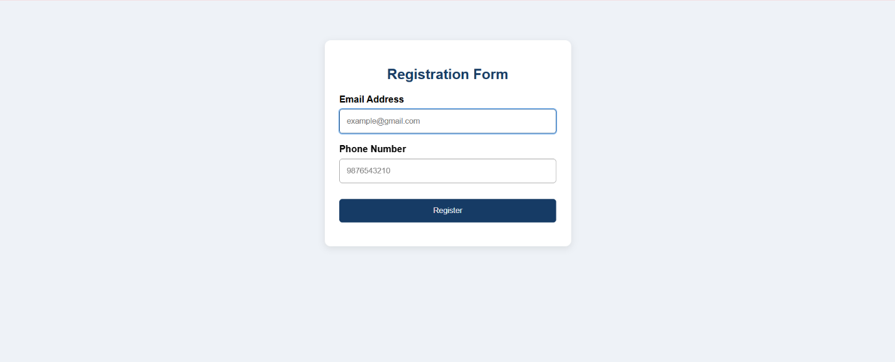

Experiment 3: CSS Layout Debugging
Aim: To identify and correct CSS layout overlapping problems using the CSS box model, Flexbox, Grid, and appropriate positioning techniques.
(a) Analyze CSS properties responsible for overlapping
Common causes of overlapping include:
1. Absolute positioning: Elements may overlap when their positions are fixed relative to a container.
2. Fixed widths: Elements may exceed the available viewport width.
3. Negative margins: These can pull elements into one another.
4. Incorrect height values: Fixed heights may not accommodate content.
5. Box model errors: Padding and borders can increase an element's total size when box-sizing is not controlled.
6. Uncontrolled overflow: Content may extend beyond its container.
Conclusion: Flexible layouts and suitable sizing properties help prevent overlapping.
(b) Explain the CSS box model
The CSS box model consists of four main parts:
Margin
Border
Padding
Content

Illustration of the CSS box model, from the outside inward.
- Content: The text, image, or other actual content.
- Padding: The space between content and border.
- Border: The boundary surrounding the content and padding.
- Margin: The space outside the border that separates neighboring elements.
Using box-sizing: border-box ensures that an element's declared width includes its padding and border, simplifying responsive sizing.
(c) Debug the layout using positioning techniques
The following CSS techniques can be used:
- Relative positioning: Moves an element relative to its normal position.
- Absolute positioning: Positions an element relative to its nearest positioned ancestor; it should be used carefully for overlapping elements.
- Flexbox: Arranges items in rows or columns and distributes available space.
- Grid: Organizes items into rows and columns.
- Normal document flow: Allows elements to occupy space naturally, reducing accidental overlap
(e) Evaluate the corrected layout and suggest best practices
The corrected layout adapts to smaller screens, reduces unintended overlap, and maintains consistent spacing.
Best practices:
- Use box-sizing: border-box globally.
- Prefer Flexbox or Grid for page layout.
- Avoid unnecessary fixed widths and heights.
- Use relative units such as %, rem, and fr where appropriate.
- Use media queries at suitable breakpoints.
- Avoid excessive absolute positioning.
- Test with long text, large images, and different browser window sizes.
- Inspect the browser's developer tools to identify overflow and layout errors.
